SONNETS OF BEAUTIFUL WONDERS
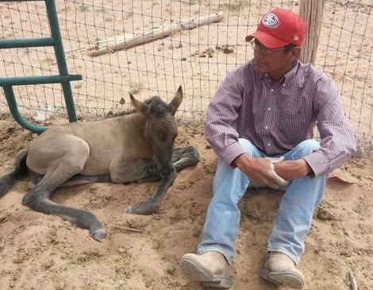
How do I love horses, let me count the ways
The love of five beautiful majestic creatures
Is like no other. The feeling of calmness I get
From listening to them eat hay. The vrmm coming
from the road brings eagerness at the gate to greet
us for food, a ride, or just a gentle hug. The amazing
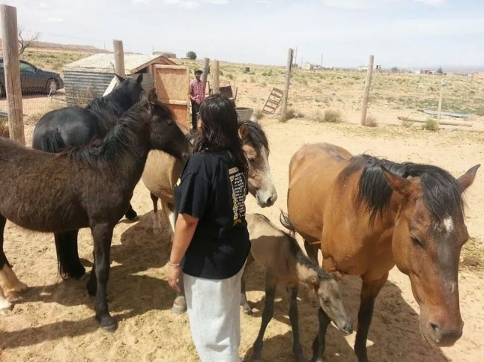
Love, honesty, loyalty, and trustworthiness they all
offer our family is like the royal family. Its amazing
how much energy they use when running and
cutting cattle with careful eyes—brings me
pride that “Yes, we are family and they are
ours.” So many others watch with envious eyes
for what we have because of all their wonderful
characteristics and love for us.
By Serena Jimmy

